dye

WHAT WE ASK OF TREES TTTtRTTRTREES TREES

CONSIDER PLEASE

oxygen

piano keys

rayon - books

fishing floats - inks

telephone poles

varnish - atlases and maps

price tags - ping pong balls

tires - umbrella handles - signs

automobile instrument panels

space craft reentry shields - newspaper

photographic film – newspapers - posters

thread spools – handbag handles - statues

road building materials - insulation

shatterproof glass - artificial vanilla flavoring

cork - vacuum cleaner bags - matches - stadium seats

adhesives – decorations – turpentine – camphor - waxes

fireworks - crayons - tannin – charcoal - pine oil - pitch

musical instruments - perches for birds of prey - toilet paper

milk cartons - flooring - bark for landscaping - cardboard

grocery bags – furniture - chewing gum - paper towels

oil spill control agents - Christmas trees – paper napkins

lamp bases - cosmetics - roofs - baby foods - cider – vitamins

cooking utensils – embroidery hoops – lacquer – pallets - rubber gloves

mulch - clean water - golf tees - egg cartons - nail polish - fence posts - toys

toothpaste – picture frames – syrup – antacids – shampoo - rubber gloves

menthol - electrical outlets - medicines - energy for electricity - plates and bowls

sausage casings - gift wrapping paper – rulers - wooden blocks – houses - notebook paper

plywood - paper plates - computer casings - stain remover - coffee filters - toothpicks

movie tickets - carpet and upholstery backsides - imitation bacon – diapers - horse corrals

postcards - tax forms - sponges - shade - particle board - shoe polish - luggage - bowling alley lanes

postage stamps – colognes - animal bedding - irrigation piping - fruit pie filling - golf balls - game boards

suspending agent for drinking soda – pencils - dry wall - baby cribs – placemats – lumber - kites

magazines-ice cream thickener – baskets - birthday cards - broom sticks – cider - ceiling tiles

packaging - backyard play sets - axe handle - food labels - 2X4s - candy wrappers

scenery - party invitations – disinfectants - CD inserts - gummed tape - fruit

railroad ties - shelter belts – puzzles – swings - baking cups

toilet paper - cutting boards

benches - bird houses

stereo speakers

garden stakes

stairways - beds

tables - barrels

window frames

bulletin boards

linoleum - seesaws

fishing boats - billboards

disposable medical clothing

church pews - totem poles - desks

(Image Credited to Idaho Forest Products Commission)

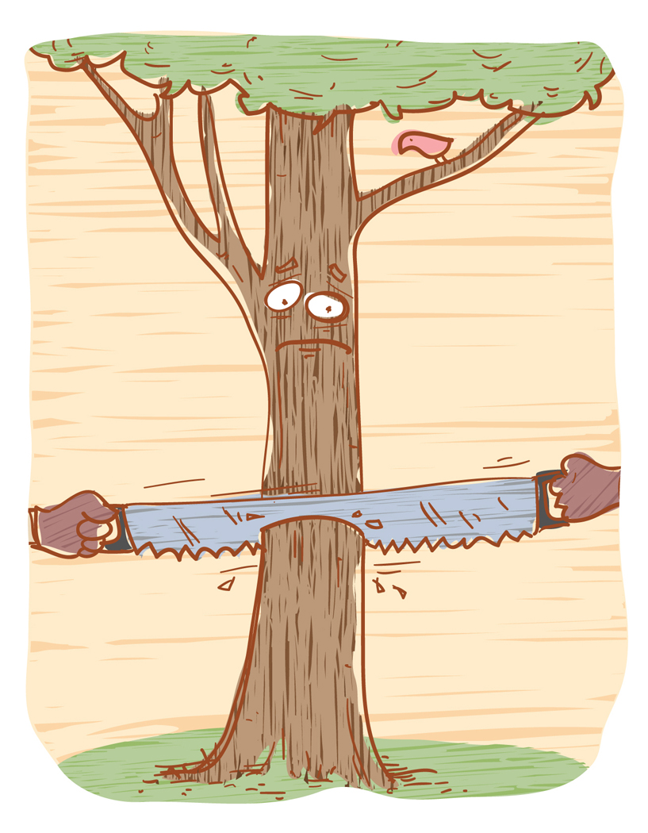

**DID YOU KNOW?**

In just one year the average American consumes enough wood and paper to make up a tree 100 feet tall and 16 inches in diameter.

Be a tree detective in your home.

Make a list of all the tree products you find.

___________ ___________ ___________

___________ ___________ ___________

___________ ___________ ___________

___________ ___________ ___________

___________ ___________ ___________

___________ ___________ ___________

___________ ___________ ___________

___________ ___________ ___________

C:\Users\Gillian\AppData\Local\Microsoft\Windows\Temporary Internet Files\Content.IE5\B37JHB12\MC900290586[1].wmfHow might you use less of a tree in an average year?

____________________________________

____________________________________

____________________________________

____________________________________

____________________________________

____________________________________

Southern California Bluebird Club Cavity Conservation Initiative [www.socalbluebirds.org](http://www.socalbluebirds.org). A tax-exempt organization