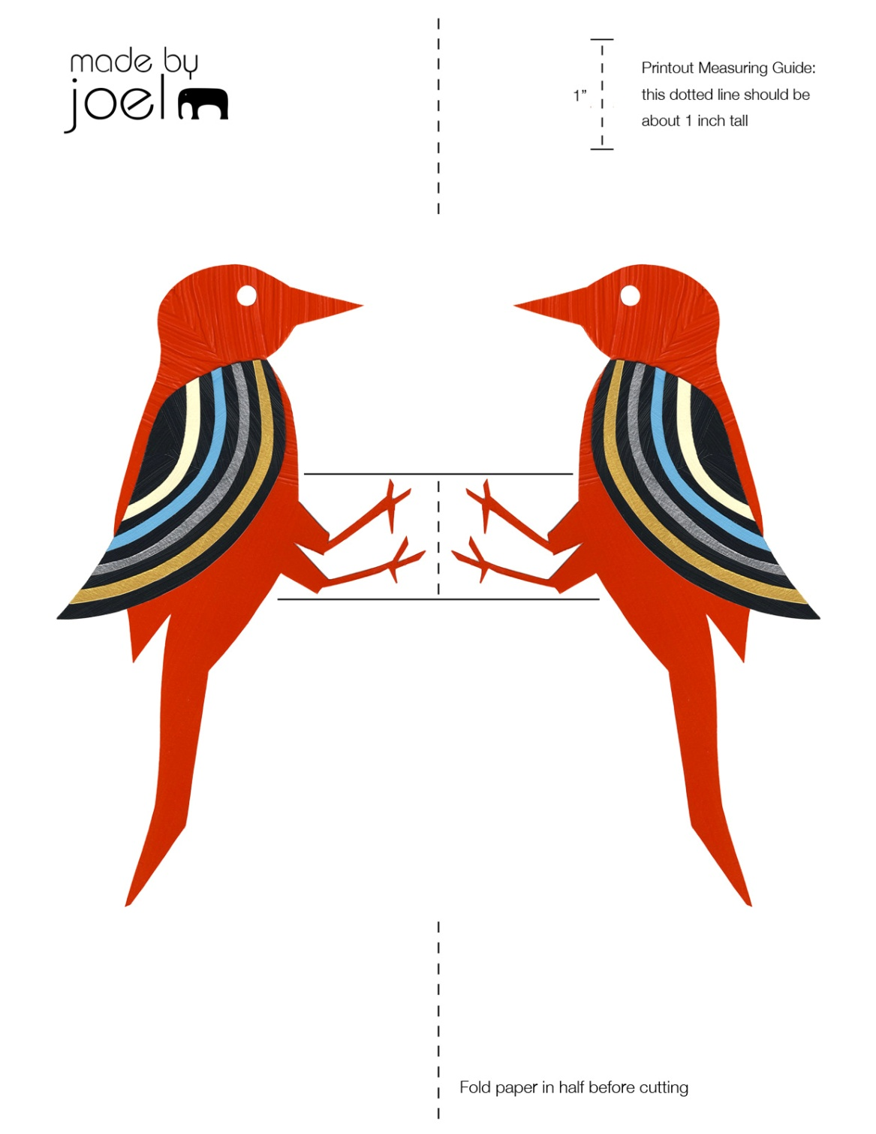

Cut and glue a section of drinking straw the length of the paper as shown.

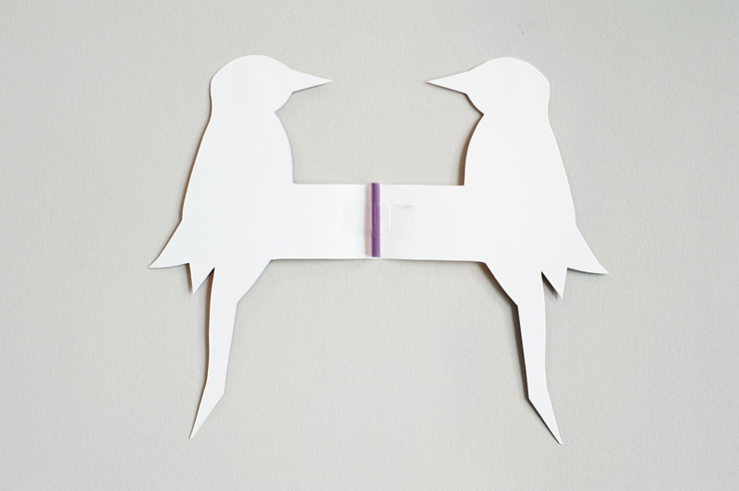

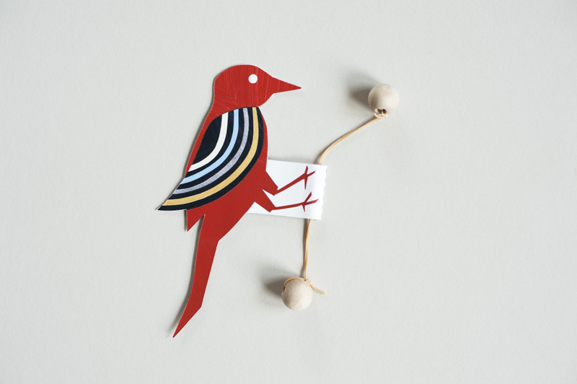

Cut a narrow rubber band in half and thread it through the straw. Secure ends to beads. Glue bird together. Hold both ends of the rubber band with the bird first positioned at the top; stretch it tight in a vertical position and shake it a little. Enjoy the woodpecker as it bobs down the rubber band!