NAME:_________ Age:__
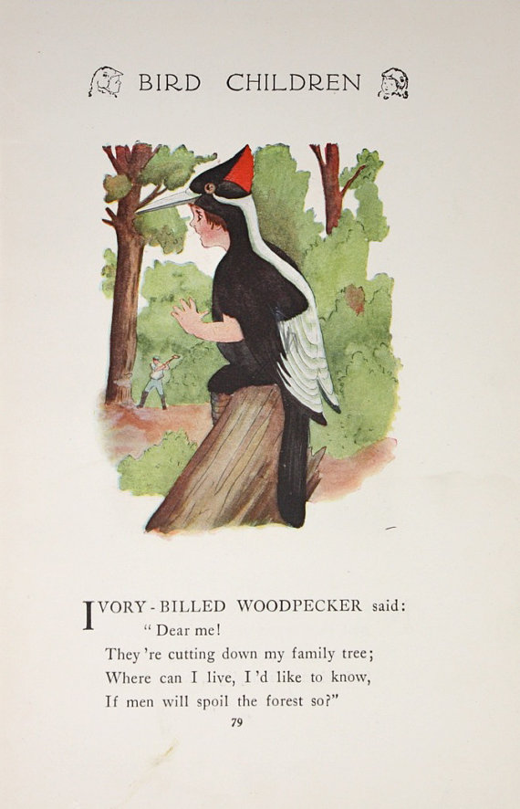
WHAT I LEARNED ABOUT WOODPECKERS TODAY:

HOW CAN PEOPLE HELP WOODPECKERS:

The Southern California Bluebird Club www.socalbluebirds.org A non-profit 501 (c ) (3) organization

